**A**

**REPORT**

**ON**

**Inventory Management System**

*Submitted in the partial fulfillment of requirement for the award of the degree of*

**Bachelor of Technology (B.Tech.)**

**in**

**Computer Science and Engineering**



**Submitted By: Submitted To:**

**Deepak-L - 2115000315 Mr. Akash Kumar choudhary**

**Aditya Rai -G– 2115000074 Assistant professor**

**Priyanshu -L– 2115000778 Computer science and**

**Shiv Kumar Dixit-M-2115000944 Engineering**

**DECLARATION OF STUDENT**

I hereby declare that the work, which is being presented in the Project Report, entitled **"** **Inventory Management System "** in partial fulfilment for the award of Degree of Bachelor of Technology'' in Deptt. Of Computer Science and Engineering and submitted to the Department of Computer Science and Engineering , GLA University, is a record of my own investigations carried under the Guidance of **Mr. Akash Kumar choudhary** Department of Computer Science and Engineering,

**GLA University**

I have not submitted the matter presented in this Project Report anywhere for the award of any other Degree.

**(Name and Signature of Candidates)**

**Deepak-L-2115000315**

**Priyanshu-L-2115000778**

**Aditya Rai-G-15000074**

**Shiv Kumar Dixit-M-2115000944**

**Counter Signed by**

Mr. Akash Kumar choudhary

**ACKNOWLEDGEMENT**

It is my pleasure to be indebted to various people, who directly or indirectly contributed in the development of this work and who influenced our thinking, behavior and acts during the course of study.

We express our sincere gratitude to **Mr. Akash Kumar choudhary**, for providing us an opportunity to undergo this Project as the part of the curriculum.

We are thankful to **Mr. Akash Kumar choudhary** for his support, cooperation, and motivation provided to us during the training for constant inspiration, presence and blessings.

We would also like to thank our **H.O.D Mr.Rohit Agarwal** for her valuable suggestions which helps us lot in completion of this project.

We also extend our sincere appreciation to **Mr. Akash Kumar choudhary**  who provided his valuable suggestions and precious time in accomplishing our Project report.

Lastly, we would like to thank the almighty and our parents for their moral support and friends with whom we shared our day-to-day experience and received lots of suggestions that improved our quality of work.

**Deepak.-L-2115000315**

**Priyanshu-L-2115000778**

**Aditya Rai-G-15000074**

**Shiv Kumar Dixit-M-2115000944**

**ABSTRACT**

The Inventory Management System (IMS) plays a pivotal role in the efficient functioning of organizations across various industries. This abstract provides an overview of the key components, functionalities, and benefits associated with an advanced Inventory Management System.

The IMS consists of key components, including real-time inventory tracking, centralized data management, order fulfillment automation, and robust reporting and analytics. These components collectively contribute to the system's functionalities, such as barcode scanning for accurate data entry, proactive alerts and notifications, and seamless integration with other business systems.

The benefits of implementing an IMS are manifold. It leads to cost reduction through process automation, improves accuracy in inventory records, and enhances customer satisfaction by ensuring efficient order fulfillment. The system's ability to generate detailed reports and analytics empowers organizations with valuable insights for data-driven decision-making.

In conclusion, the Inventory Management System is a strategic asset for organizations aiming to optimize operations, reduce costs, and provide superior services. Its integration of technology and automation aligns with the demands of modern business, making it an indispensable tool in the dynamic landscape of inventory management

**Table of Contents**

**1. Introduction**

1.1 Background

1.2 Purpose of the Inventory Management System

**2. Key Components**

2.1 Inventory Tracking

2.2 Data Management

2.3 Order Management

2.4 Reporting and Analytics

**3. Functionalities**

3.1 Barcode Scanning

3.2 Alerts and Notifications

3.3 Integration Capabilities

**4. Benefits**

4.1 Cost Reduction

4.2 Improved Accuracy

4.3 Enhanced Customer Satisfaction

**5.Code**

**6. OutPut**

**7.Technology**

* **HTML**
* **CSS**
* **Javascript**
* **Php**
* **Mysql**

**8.** **Reference**

**9. Conclusion**

**Introduction**

1.1 **Background:**

The Inventory Management System (IMS) has become integral to modern business operations. In an era of heightened competition and rapidly changing market dynamics, efficient control and management of inventory play a crucial role in sustaining organizational success. This section provides a brief overview of the historical context and the evolving significance of inventory management.

1.2 **Purpose of the Inventory Management System:**

This subsection outlines the specific goals and objectives of implementing an Inventory Management System. Whether it's to streamline processes, reduce costs, or enhance customer satisfaction, clarifying the purpose sets the stage for understanding the system's broader impact on organizational performance.

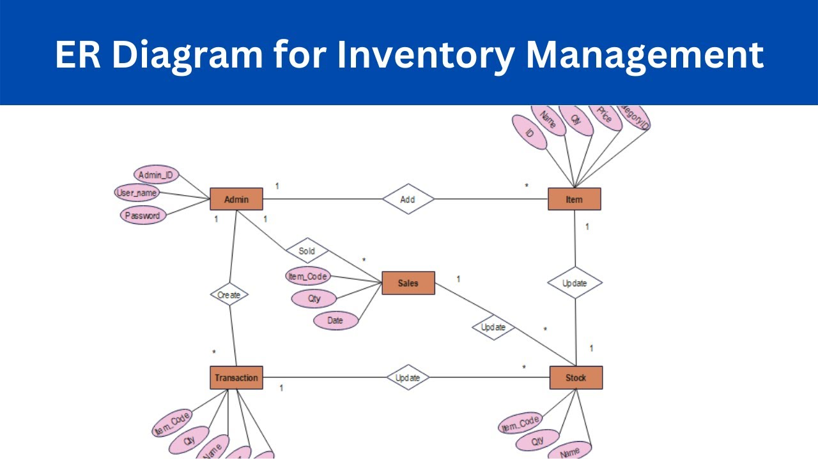

**Key Components**

2.1 **Inventory Tracking:**

Real-time tracking is the backbone of IMS, ensuring organizations have accurate and up-to-date information on the movement of goods within their supply chain. This component explores how inventory tracking minimizes errors, prevents stockouts, and improves overall inventory control.

2.2 **Data Management:**

Centralized data management is essential for maintaining a cohesive and accurate record of inventory, suppliers, and customers. This section delves into the role of data management in supporting data-driven decision-making and ensuring consistency across the organization.

2.3 **Order Management:**

IMS automates the order fulfillment process, from order creation to delivery. This component discusses how the system optimizes the order management workflow, reduces lead times, and contributes to a more efficient supply chain.

2.4 **Reporting and Analytics:**

Generating detailed reports and analytics is a powerful feature of IMS. This section explores how these insights contribute to informed decision-making by providing valuable information on inventory turnover, demand forecasting, and supplier performance.

**Functionalities**

3.1 **Barcode Scanning:**

Barcode scanning is a key functionality that enhances data entry accuracy and expedites processes like receiving and picking. This section explains the importance of barcode technology in the context of inventory management.

3.2 **Alerts and Notifications:**

The IMS includes alert mechanisms to notify users of critical events such as low stock levels or order status updates. This functionality ensures timely interventions and proactive management of potential issues.

3.3 **Integration Capabilities:**

IMS seamlessly integrates with other business systems, such as ERP and POS. This section explores how integration enhances overall organizational efficiency by maintaining a cohesive flow of information.

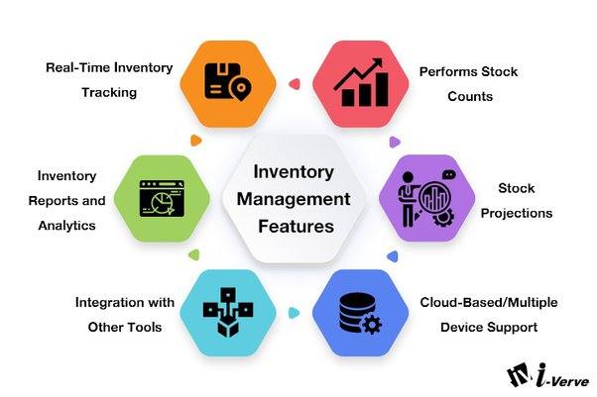

**Benefits**

4.1 **Cost Reduction:**

Automation of inventory processes leads to cost savings by reducing labor costs and minimizing the risk of errors. This section discusses how IMS contributes to overall cost reduction within the organization.

4.2 **Improved Accuracy:**

Utilizing technology such as barcode scanning and automated data entry improves the accuracy of inventory records. This component explores how enhanced accuracy positively impacts overall operations.

4.3 **Enhanced Customer Satisfaction:**

Efficient order fulfillment and reduced lead times contribute to improved customer satisfaction. This section discusses how IMS plays a role in meeting customer expectations and fostering loyalty. 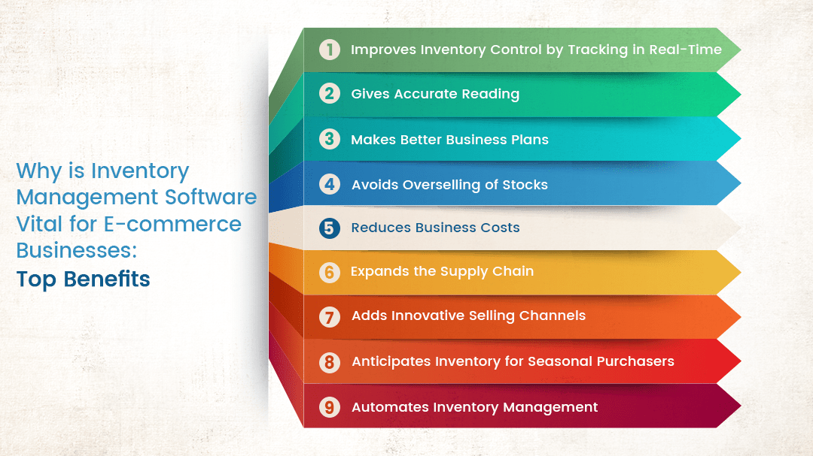

**Code**

* **Index.php**

**<?php**

**ob_start();**

**session_start();**

**include('inc/header.php');**

**include 'Inventory.php';**

**$inventory = new Inventory();**

**$inventory->checkLogin();**

**?>**

**<script src="js/jquery.dataTables.min.js"></script>**

**<script src="js/dataTables.bootstrap.min.js"></script>**

**<link rel="stylesheet" href="css/dataTables.bootstrap.min.css" />**

**<script src="js/common.js"></script>**

**<?php include('inc/container.php');?>**

**<div class="container">**

**<?php include("menus.php"); ?>**

**<div class="row">**

**<div class="col-lg-12">**

**<div class="card card-default rounded-0 shadow">**

**<div class="card-header">**

**<div class="row">**

**<div class="col-lg-10 col-md-10 col-sm-8 col-xs-6">**

**<h3 class="card-title">Inventory</h3>**

**</div>**

**</div>**

**</div>**

**<div class="card-body">**

**<div class="row"><div class="col-sm-12 table-responsive">**

**<table id="inventoryDetails" class="table table-bordered table-striped">**

**<thead><tr>**

**<th>#</th>**

**<th>Product/Code</th>**

**<th>Starting Inventory</th>**

**<th>Inventory Recieved</th>**

**<th>Inventory Shipped</th>**

**<th>Inventory on Hand</th>**

**</tr></thead>**

**</table>**

**</div></div>**

**</div>**

**</div>**

**</div>**

**</div>**

**</div>**

**<?php include('inc/footer.php');?>**

* **Login.php**

**<?php**

**ob_start();**

**session_start();**

**include('inc/header.php');**

**$loginError = '';**

**if (!empty($_POST['email']) && !empty($_POST['pwd'])) {**

**include 'Inventory.php';**

**$inventory = new Inventory();**

**$login = $inventory->login($_POST['email'], $_POST['pwd']);**

**if(!empty($login)) {**

**$_SESSION['userid'] = $login[0]['userid'];**

**$_SESSION['name'] = $login[0]['name'];**

**header("Location:index.php");**

**} else {**

**$loginError = "Invalid email or password!";**

**}**

**}**

**?>**

**<style>**

**html,**

**body,**

**body>.container {**

**height: 95%;**

**width: 100%;**

**}**

**body>.container {**

**display:flex;**

**flex-direction:column;**

**align-items:center;**

**justify-content:center;**

**}**

**#title{**

**text-shadow:2px 2px 5px #000;**

**}**

**</style>**

**<?php include('inc/container.php');?>**

**<h1 class="text-center my-4 py-3 text-light" id="title">Inventory Management System</h1>**

**<div class="col-lg-4 col-md-5 col-sm-10 col-xs-12">**

**<div class="card rounded-0 shadow">**

**<div class="card-header">**

**<div class="card-title h3 text-center mb-0 fw-bold">Login</div>**

**</div>**

**<div class="card-body">**

**<div class="container-fluid">**

**<form method="post" action="">**

**<div class="form-group">**

**<?php if ($loginError ) { ?>**

**<div class="alert alert-danger rounded-0 py-1"><?php echo $loginError; ?></div>**

**<?php } ?>**

**</div>**

**<div class="mb-3">**

**<label for="email" class="control-label">Email</label>**

**<input name="email" id="email" type="email" class="form-control rounded-0" placeholder="Email address" autofocus="" value="<?= isset($_POST['email']) ? $_POST['email'] : '' ?>" required>**

**</div>**

**<div class="mb-3">**

**<label for="password" class="control-label">Password</label>**

**<input type="password" class="form-control rounded-0" id="password" name="pwd" placeholder="Password" required>**

**</div>**

**<div class="d-grid">**

**<button type="submit" name="login" class="btn btn-primary rounded-0">Login</button>**

**</div>**

**</form>**

**</div>**

**</div>**

**</div>**

**</div>**

**<?php include('inc/footer.php');?>**

* **Menu.php**

**<nav class="navbar navbar-dark bg-dark bg-gradient navbar-expand-lg navbar-expand-md my-3">**

**<div class="container-fluid">**

**<button class="navbar-toggler" type="button" data-bs-toggle="collapse" data-bs-target="#navbarNav"**

**aria-controls="navbarNav" aria-expanded="false" aria-label="Toggle navigation">**

**<span class="navbar-toggler-icon"></span>**

**</button>**

**<div class="collapse navbar-collapse" id="navbarNav">**

**<ul class="nav navbar-nav menus">**

**<li class="nav-item"><a class="nav-link" href="index.php" id="index_menu">Home</a></li>**

**<li class="nav-item"><a class="nav-link" href="customer.php" id="customer_menu">Customer</a></li>**

**<li class="nav-item"><a class="nav-link" href="category.php" id="category_menu">Category</a></li>**

**<li class="nav-item"><a class="nav-link" href="brand.php" id="brand_menu">Brand</a></li>**

**<li class="nav-item"><a class="nav-link" href="supplier.php" id="supplier_menu">Supplier</a></li>**

**<li class="nav-item"><a class="nav-link" href="product.php" id="product_menu">Product</a></li>**

**<li class="nav-item"><a class="nav-link" href="purchase.php" id="purchase_menu">Purchase</a></li>**

**<li class="nav-item"><a class="nav-link" href="order.php" id="order_menu">Orders</a></li>**

**</ul>**

**</div>**

**<ul class="nav navbar-nav">**

**<li class="dropdown position-relative">**

**<button type="button" class="badge bg-light border px-3 text-dark rounded-pill dropdown-toggle" id="dropdownMenuButton1" data-bs-toggle="dropdown" data-bs-toggle="dropdown" aria-expanded="false">**

**<span class="badge badge-pill bg-danger count"></span>**

**<?php echo $_SESSION['name']; ?>**

**</button>**

**<ul class="dropdown-menu" aria-labelledby="dropdownMenuButton1">**

**<li><a class="dropdown-item" href="action.php?action=logout">Logout</a></li>**

**</ul>**

**</li>**

**</ul>**

**</div>**

**</nav>**

* **Style.CSS**

**html,**

**body {**

**height: 100% !important;**

**width: 100% !important;**

**}**

**.footer {**

**position: absolute;**

**bottom: 0;**

**width: 100%;**

**height: 60px;**

**background-color: #f5f5f5;**

**padding-top: 15px;**

**}**

**OutPut**

**Login**

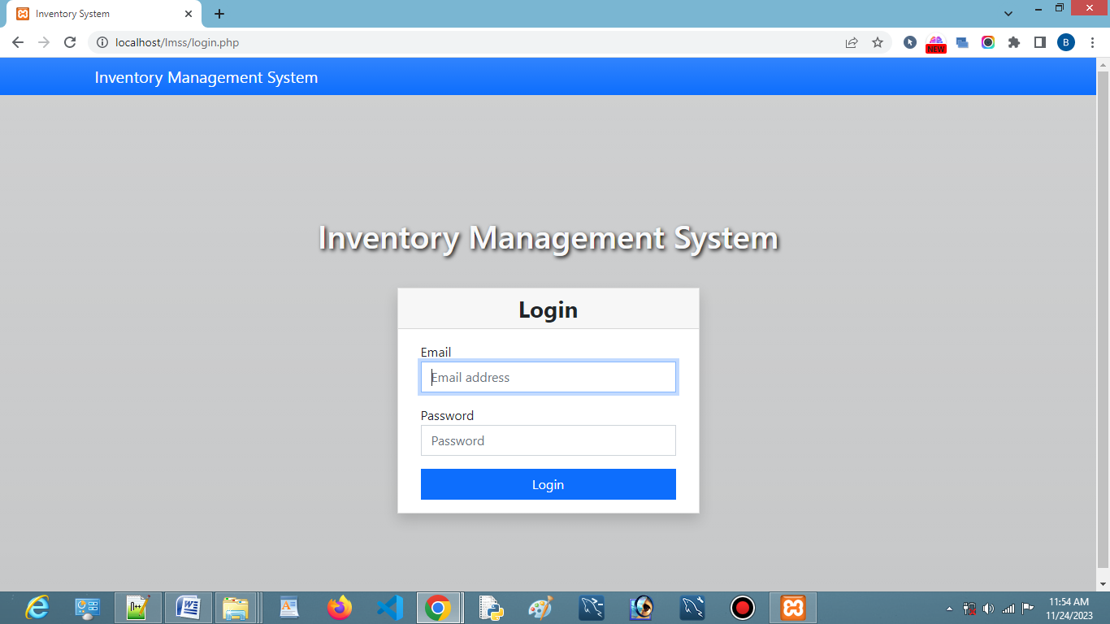

**Home**

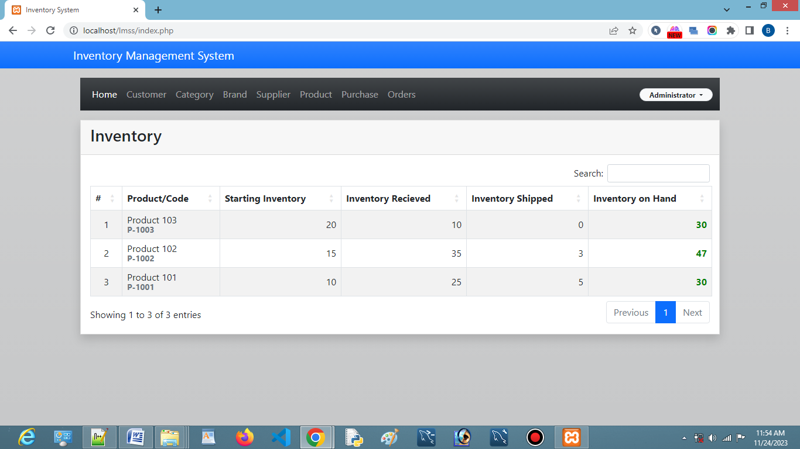

**Customer**

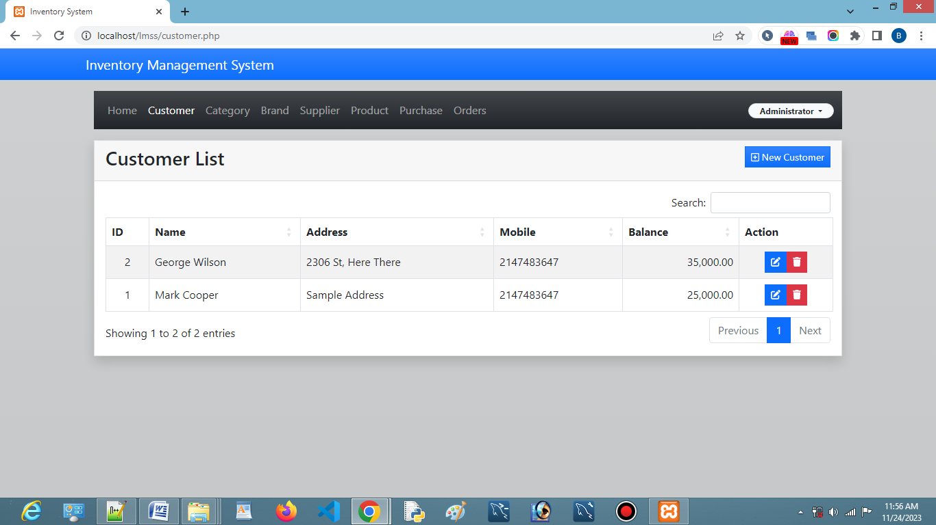

**Category**

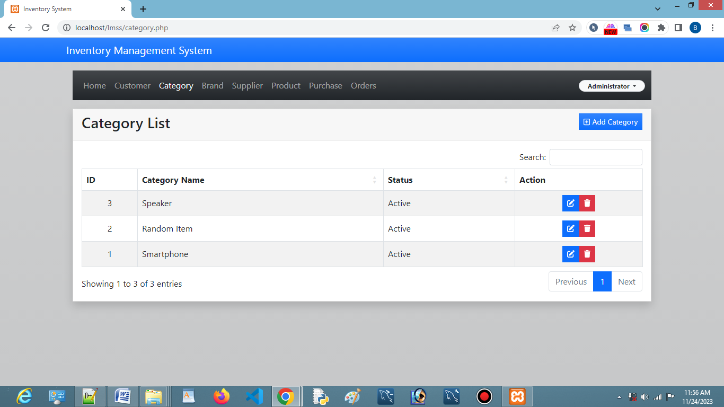

**Brand**

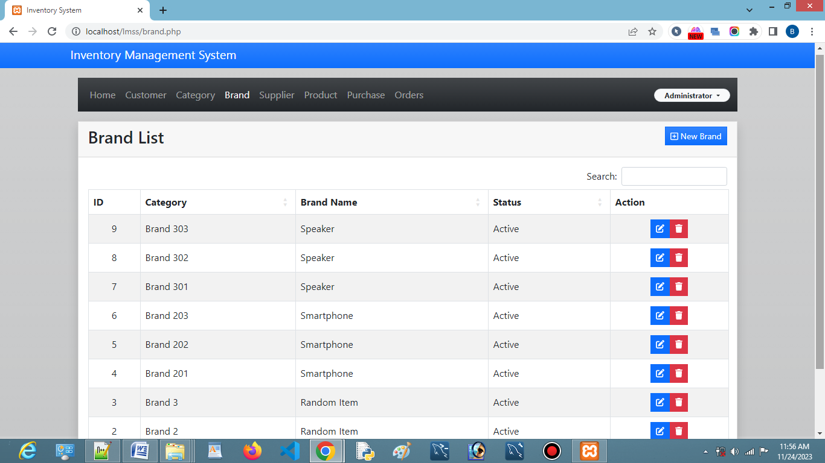

**Supplier**

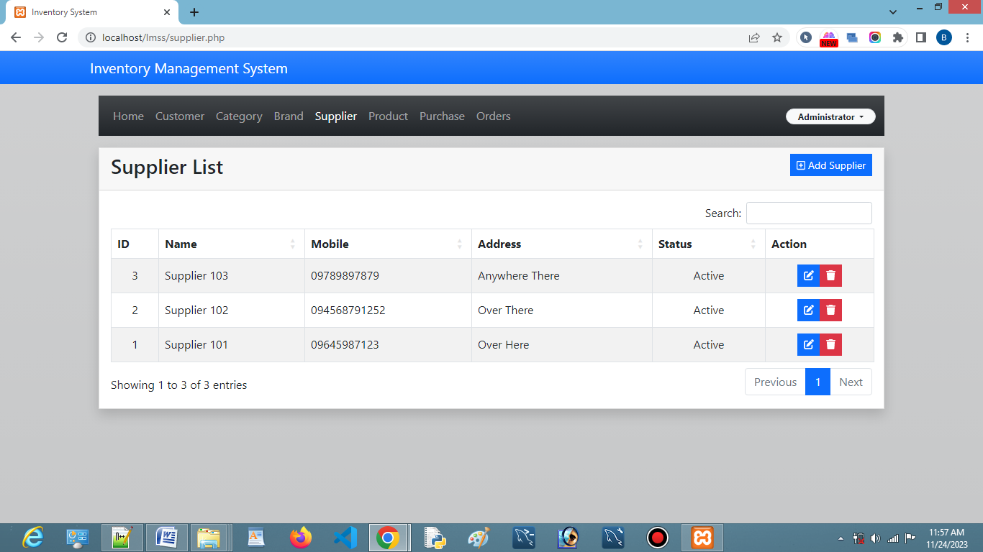

**Product**

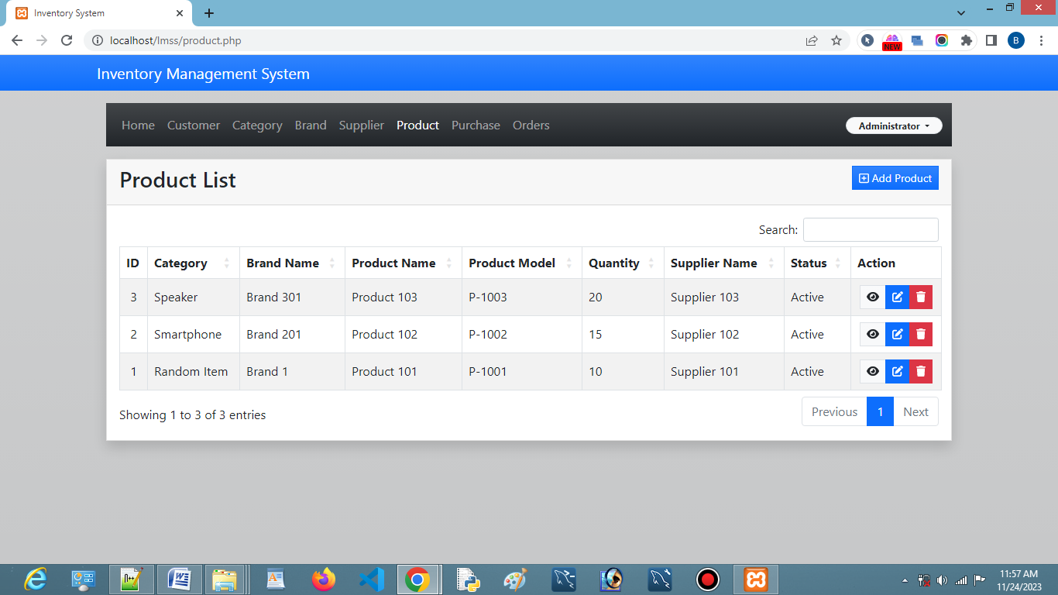

**Purchase**

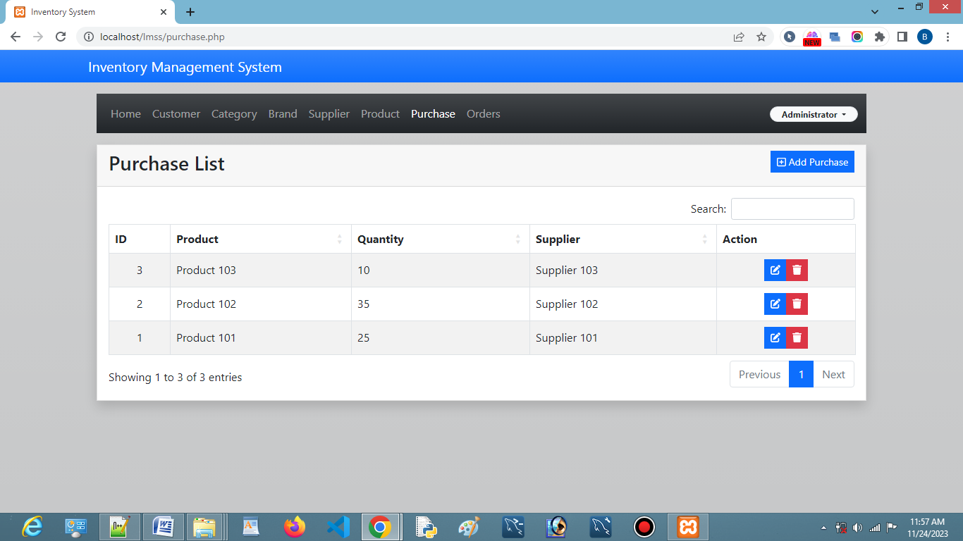

**Orders**

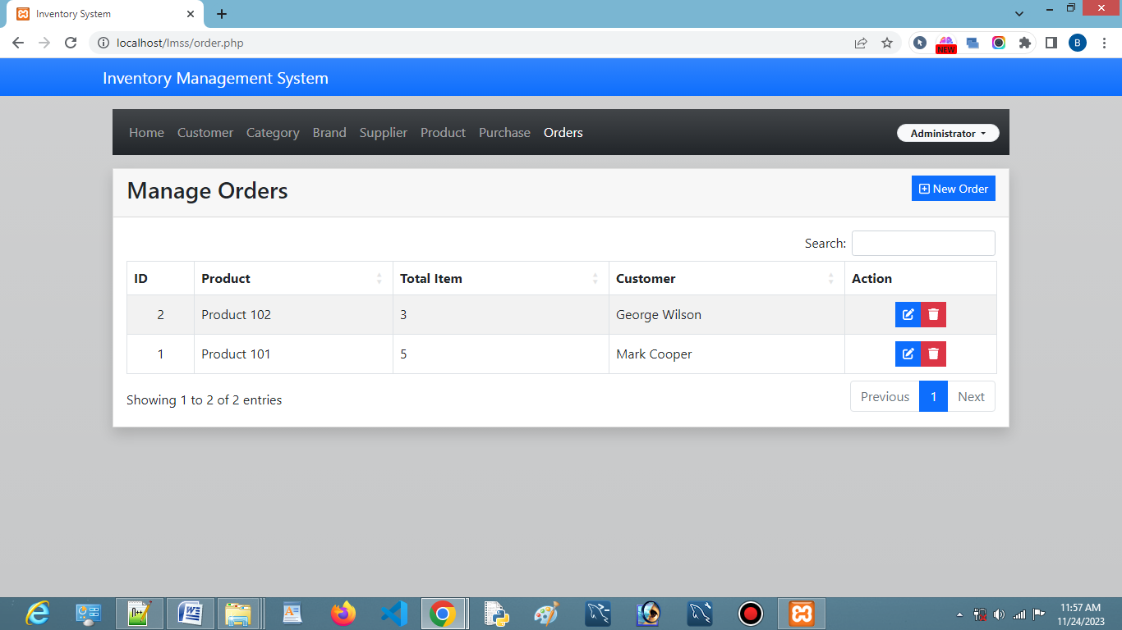

**DataBase**

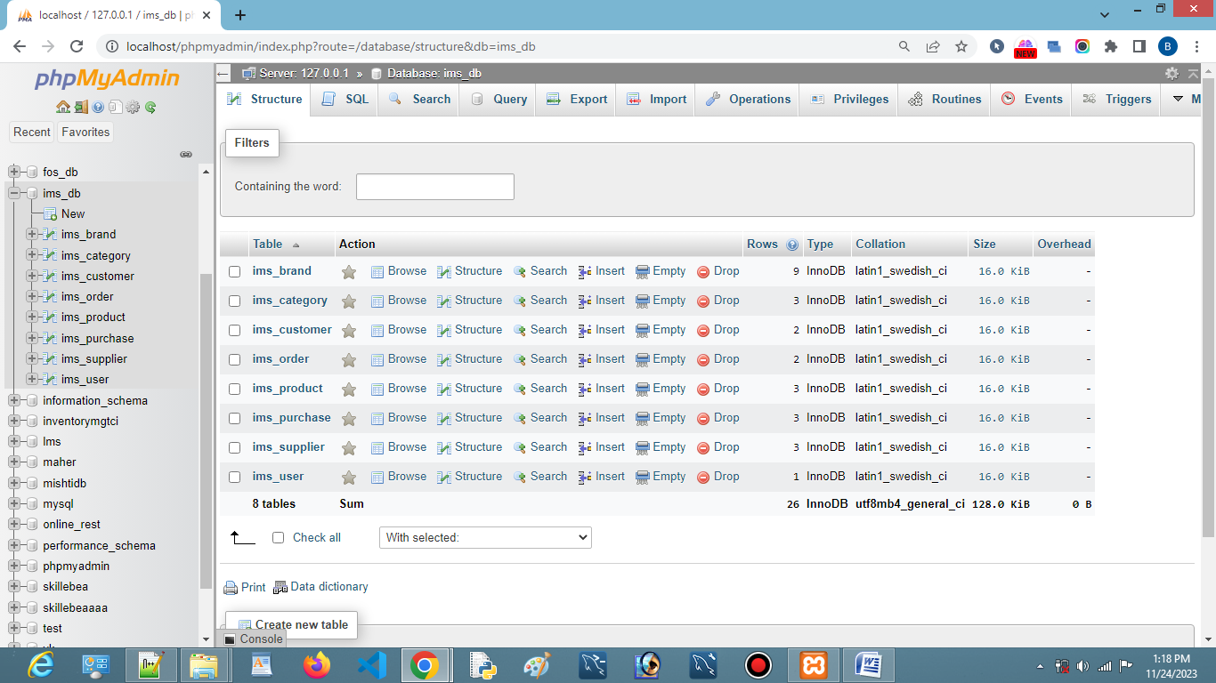

**Files**

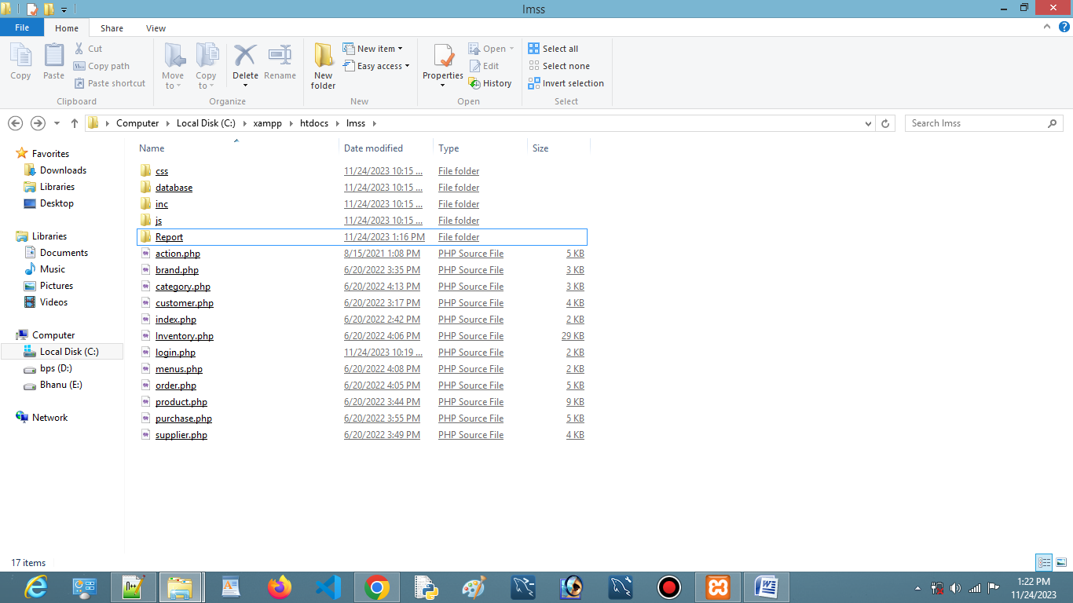

**Technology**

* **What is HTML ?**

HTML, which stands for HyperText Markup Language, is the standard markup language used to create and design the structure of web pages and web applications. It is an essential component of the World Wide Web and is used in conjunction with other technologies like Cascading Style Sheets (CSS) and JavaScript to build dynamic and interactive websites.

HTML uses a system of markup tags to annotate the content of a web page. These tags define the structure of the document, such as headings, paragraphs, lists, links, images, forms, and other elements. Each HTML tag consists of an opening tag, content, and a closing tag, and they are enclosed within angle brackets (**<** and **>**).

* **<!DOCTYPE html>** declares the document type and version of HTML being used (HTML5 in this case).
* **<html>** is the root element of the HTML document.
* **<head>** contains meta-information about the HTML document, such as the title that appears in the browser tab.
* **<body>** contains the content of the HTML document, including headings, paragraphs, lists, and images.
* **<h1>** defines a top-level heading.
* **<p>** defines a paragraph.
* **<ul>** and **<li>** define an unordered list and list items, respectively.
* **<img>** embeds an image with a specified source (**src**) and alternative text (**alt**).

HTML provides the basic structure and semantics of a web page, while CSS is used for styling and layout, and JavaScript is used for adding interactivity and dynamic behavior to the web page. Together, these technologies form the foundation of modern web development.

* **What is CSS ?**

CSS, or Cascading Style Sheets, is a style sheet language used for describing the presentation and layout of documents written in HTML and XML. In simpler terms, CSS allows web developers to control the appearance of web pages, defining how elements should be displayed on a screen, printed, or even spoken.

CSS allows the separation of document content (HTML) from document presentation (CSS). This separation makes it easier to maintain and update the visual style of a website without altering its content.

CSS uses selectors to target HTML elements and declarations to define the style of those elements

* **What is javascript?**

JavaScript is a high-level, versatile, and interpreted programming language primarily known for its role in building dynamic and interactive web pages. It is a core technology for front-end web development and is widely used to enhance user experience by enabling client-side interactivity within web browsers.

.

* **What is PHP ?**

PHP, which stands for Hypertext Preprocessor, is a server-side scripting language widely used for web development. PHP is embedded within HTML code and is executed on the server, generating dynamic content that is then sent to the client's web browser. It is especially well-suited for building dynamic websites and web applications.

* **What is MYSQL**

MySQL is an open-source relational database management system (RDBMS) that is widely used for managing and organizing data. It is known for its reliability, performance, and ease of use. MySQL is a part of the LAMP (Linux, Apache, MySQL, PHP/Perl/Python) stack and is commonly used in conjunction with various programming languages for web development.

.

**References**

**Odoo Inventory:**

* **Website: https://www.odoo.com/inventory**

**Zoho Inventory:**

* **Website: https://www.zoho.com/in/inventory/**

**Fishbowl:**

* **Website: https://www.fishbowlinventory.com/**

**TradeGecko:**

* **Website: https://quickbooks.intuit.com/quickbooks-commerce/**

**inFlow Inventory:**

* **Website:** <https://www.inflowinventory.com/>

**Conclusion:**

This section provides a brief summary of the key points discussed in the document, emphasizing the significance of implementing an advanced Inventory Management System in today's business landscape. It may also touch upon potential future developments in inventory management technology.